2018 KAWASAKI Z900RS
February 27, 2018 (Tuesday)
KAWASAKI MOTORS (MALAYSIA) SDN. BHD. (167131-V)
KAWASAKI BRINGS ADVANCED TECHNOLOGY TO A RETRO MODEL
The new Kawasaki Z900RS is Kawasaki’s long awaited foray into the retro genre of motorcycling. It is a true throwback to its 1970’s predecessor, the famed Kawasaki Z1.
Kawasaki is bringing class leading performance and technology to another category of motorcycles, the retro bike class. In building the Z900RS, Kawasaki has meticulously crafted one of the most authentic retro bikes in appearance and design, paying homage to the original Z1, all while tastefully incorporating modern technology and features.
Developed for riders in search of a well-rounded bike that is not only rich in history and character, but also packed with modern technology and handling features, the Z900RS is powered by a 948cc in-line four engine, features a modern trellis frame, and modern suspension components that bring an unmatched level of performance to the retro bike category.
The sleek sweeping contours and meticulous fit and finish of the Z1 redefined the standards of motorcycle design in the 1970’s. Kawasaki has applied the same meticulous attention to detail in building the Z900RS, from the iconic teardrop gas tank to the simple uncluttered engine design, all the way down to the retro themed headlight and tail cowl.
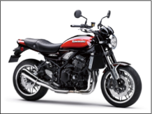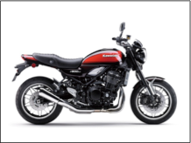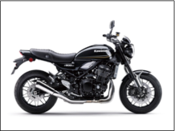

The newest addition to the Z family, the Z900RS, is packed with technologically advanced components and features, including the 41mm inverted front forks, slipper clutch, and Kawasaki Traction Control (KTRC). The bike also has some of its own new features as well, such as Kawasaki’s first fully tuned exhaust note, designed to elicit rider response when the 948cc in-line four cylinder engines roars to life, idling, and low speed riding.
Highlights of the 2018 Kawasaki Z900RS:
- Strong, Smooth In-Line Four Engine
- NEW Kawasaki Tuned Exhaust Note
- Lightweight Trellis Frame
- Z1-Inspired iconic styling
The stylish appearance of the standard Z900RS is available in Metallic Flat GREEN and Candytone ORANGE.
STRONG, SMOOTH IN-LINE FOUR ENGINE & TRANSMISSION
The Z900RS, features a liquid-cooled, DOHC, 16-valve 948cc in-line four cylinder engine. Its design and configuration offer a great balance of power and manageability, delivering strong low and mid range torque that provides all riders the reassuring feeling of control. Several engine components played a crucial role in achieving the smooth, reliable, consistent power needed for the Z900RS. U
Utilizing the downdraft positioning of the 36mm throttle bodies was crucial in allowing intake air to travel in the most direct route to the combustion chamber; which is all complemented by ECU controlled sub throttles that provide silky smooth throttle response. To achieve the desired engine performance on the low-mid rpm range, compression ratio was set to 10.8:1, intake cam profiles at 248o and exhaust duration at 244o.
To facilitate smooth shifting the gearing ratio of the Z900RS was designed to have a short first gear, making it easier to launch. It also features a longer sixth gear for improved ride comfort when touring or cruising at highway speeds and also allows the engine to operate at lower rpm, which in turn results in improved fuel efficiency and reduced engine vibration. The Z900RS features a high-quality clutch with assist and slipper function working in unison with its transmission. Additionally, the back-torque limiting slipper function of the clutch contributes to stability by helping to prevent wheel hop during downshifts
KAWASAKI’S FIRST TUNED EXHAUST NOTE.
While Kawasaki in-line four cylinder engines have been historically known for their great-sounding exhausts, this is the first time that Kawasaki has used sound research to craft the model’s ideal exhaust note. Sound tuning on the Z900RS‘s engine was focused on the initial roar to life, idling, and low-speed riding where the rider is best able to enjoy the exhaust’s deep growl.
To ensure both performance and the desired sound were achieved, every aspect of the exhaust system was scrutinized: exhaust pipe length, collector design, where to position the bends, even the density of the glass wool fibers in the silencer. More than 20 renditions of the system were tested before finding the perfect match. Clever internal construction of the pre-chamber achieves a balance of sound and performance, and at low- rpm, the exhaust escapes in a straight line, while at high-rpm the exhaust is routed through an additional passage.
The high quality stainless steel exhaust system features a 4-into-1-collector layout. The header pipes and pre-chamber are built as single unit. The exhaust headers feature a double-wall construction, which helps to minimize heat discoloration and provide protection from the elements. The 28.6 mm inner diameter of the header pipes was chosen to achieve the desired low-mid range engine performance, and the larger 38.1 mm outer wall of the header pipes provides a quality finish appearance flowing from the beautifully crafted in-line four cylinder engine. The compact stainless steel megaphone-style silencer contributes to the retro design of the Z900RS. To ensure the highest quality finish possible the header pipes, pre-chamber and silencer are all treated with a special three stage buffing process: the first is done as individual parts, the second is done once the exhaust is assembled, the third stage is a final buffing process.

LIGHTWEIGHT TRELLIS FRAME
To achieve the desired weight, handling characteristics, and appearance, the Z900RS received an all- new high tensile steel trellis frame that was developed using Kawasaki’s advanced analysis technology. The lines of the frame were made as straight as possible, only utilizing bends when necessary, which has created a frame that disperses stress extremely well and offers very smooth predictable handling. Also aiding in the pursuit of lightweight and performance handling is the rigid-mounted engine, which is connected at five points to the frame: front and rear of the cylinder head, behind the cylinder, and at the top and bottom of the crankcases. Its minimalist design has helped to trim all unnecessary weight while showcasing its retro styling.
The Z900RS has a laid back and relaxed design to it, which was achieved by raising the front and lowering the rear. Along with an entirely new frame, the Z900RS also features a new upper-triple clamp, which increases the steering offset to 34 mm, which reduces trail. and contributes to light operation.
SUSPENSION
Complementing the ride comfort of the all-new performance designed trellis frame is a 41mm inverted fork and Kawasaki’s Horizontal Back-Link rear suspension design. The high-grade fork features fully adjustable 10-way compression and 12-way rebound damping, enabling riders to find their precise settings to suit their preference and riding style. Enhancing the performance of the rear is Kawasaki’s Horizontal Back-Link rear suspension design. The rear shock features fully adjustable rebound damping and preload. This arrangement contributes to mass centralization while ensuring that the suspension is located far enough from the exhaust that it is not affected by heat.
BRAKING
Handling the stopping duties of the Z900RS is a full disc brake setup featuring modern ABS. The Radial-pump front brake master cylinder commands a pair of 4-piston radial-mount monobloc calipers to grip a pair of 300 mm brake discs, providing plenty of stopping power. The rear brake features a single piston, pin-slide caliper gripping a 250 mm disc.

KAWASAKI TRACTION CONTROL (KTRC)
The Z900RS is equipped with Kawasaki TRaction Control (KTRC), which has two performance settings riders can choose from: Mode 1 prioritizes maximum forward acceleration, while Mode 2 provides rider reassurance by facilitating smooth riding on slippery surfaces.
When selected, Mode 2 utilizes the same logic and control as Mode 1,but enables riders to better negotiate both short patches of slippery terrain, such as train tracks or manhole covers, and extended stretches of other less predictable surfaces. Wheel spin is also limited when starting on a slippery surface. However, when excessive rear wheel spin occurs, Mode 2 switches to three-way control, which governs the ignition timing, fuel delivery and airflow, and engine output is reduced to a level that allows the rear wheel to regain grip. This fine control results in a very natural feeling with smooth engagement and on/off transition. Riders may also elect to turn the system off to enjoy the raw feel of riding.
RETRO STYLING
It was crucial that the appearance of the Z900RS pay homage to its predecessors, specifically the Z1. This dictated many elements of the design of the bike, such as the bodywork, the fit and finish of the engine, and even the wheels.
The centerpiece of the Z900RS is the beautiful four and a half gallon teardrop fuel tank, which is reminiscent of the Z1. The entire frame was designed around positioning and showcasing the beautiful fuel tank. The retro vibe also influenced the large 170 mm LED headlamp, which blends old school looks and modern designs. Position lamps in the high-beam chambers ensure the whole lamp appears lit, like a retro-style bulb headlamp; a convex lens and chromed headlamp ring add to the high-quality finish and appearance. The duckbill tail cowl of the Z1 also inspired the flowing design of the rear cowl on the Z900RS. The oval design of the LED taillight also pays homage to its Z1 lineage. Unlike standard LED taillights that appear as a collection of dots, the surface-emitting LED taillight lights up as a solid surface. An analogue-style speedometer and tachometer give off the retro vibe for the gauges, which is contrasted by a multi-functional LCD screen with an easy-to-read black and white display that continues the theme of blending retro styling and modern technology.
The simple, uncluttered engine design was very important to Kawasaki engineers when building the Z900RS. The engineers wanted to capture the air-cooled & carbureted feel, to really make the bike stand out in an age where electronics have become increasingly popular to find in the engine bay. The stylish engine fins were cast onto the cylinder head to create the image of an air-cooled engine. The long, flowing stainless steel header design that mates to the short, low hanging megaphone silencer are true throwback to how bikes used to be built.
The cast aluminum wheels chosen for the Z900RS feature flat spokes designed to look like classic wire-spoked wheels. Designed using Kawasaki’s advanced analysis technology, the wheels offer a balance of lightweight and stylish looks, contributing to both handling and a design suited to the retro category.
NUMEROUS ACCESSORIES
Kawasaki offers a full line of genuine accessories for the 2018 Z900RS, which enable customers to personalize their bikes to their liking in a number of different ways. Kawasaki Genuine Accessories offers a frame slider set, front axel sliders, radiator trim, and a tank pad. Kawasaki Genuine Accessories offers grip heater set, Ergo-Fit seat, and a smoked wind defector. Styling, being one of the most important elements to a motorcyclist, Kawasaki Genuine Accessories made sure to offer a wide variety of options: retro Kawasaki tank emblem set, oil filler cap (Black, Gold or White), KYB fork cap set (Black or Gold), silver gauge trim, passenger grab bar, side grip set, Akrapovic slip on muffler and a center stand.

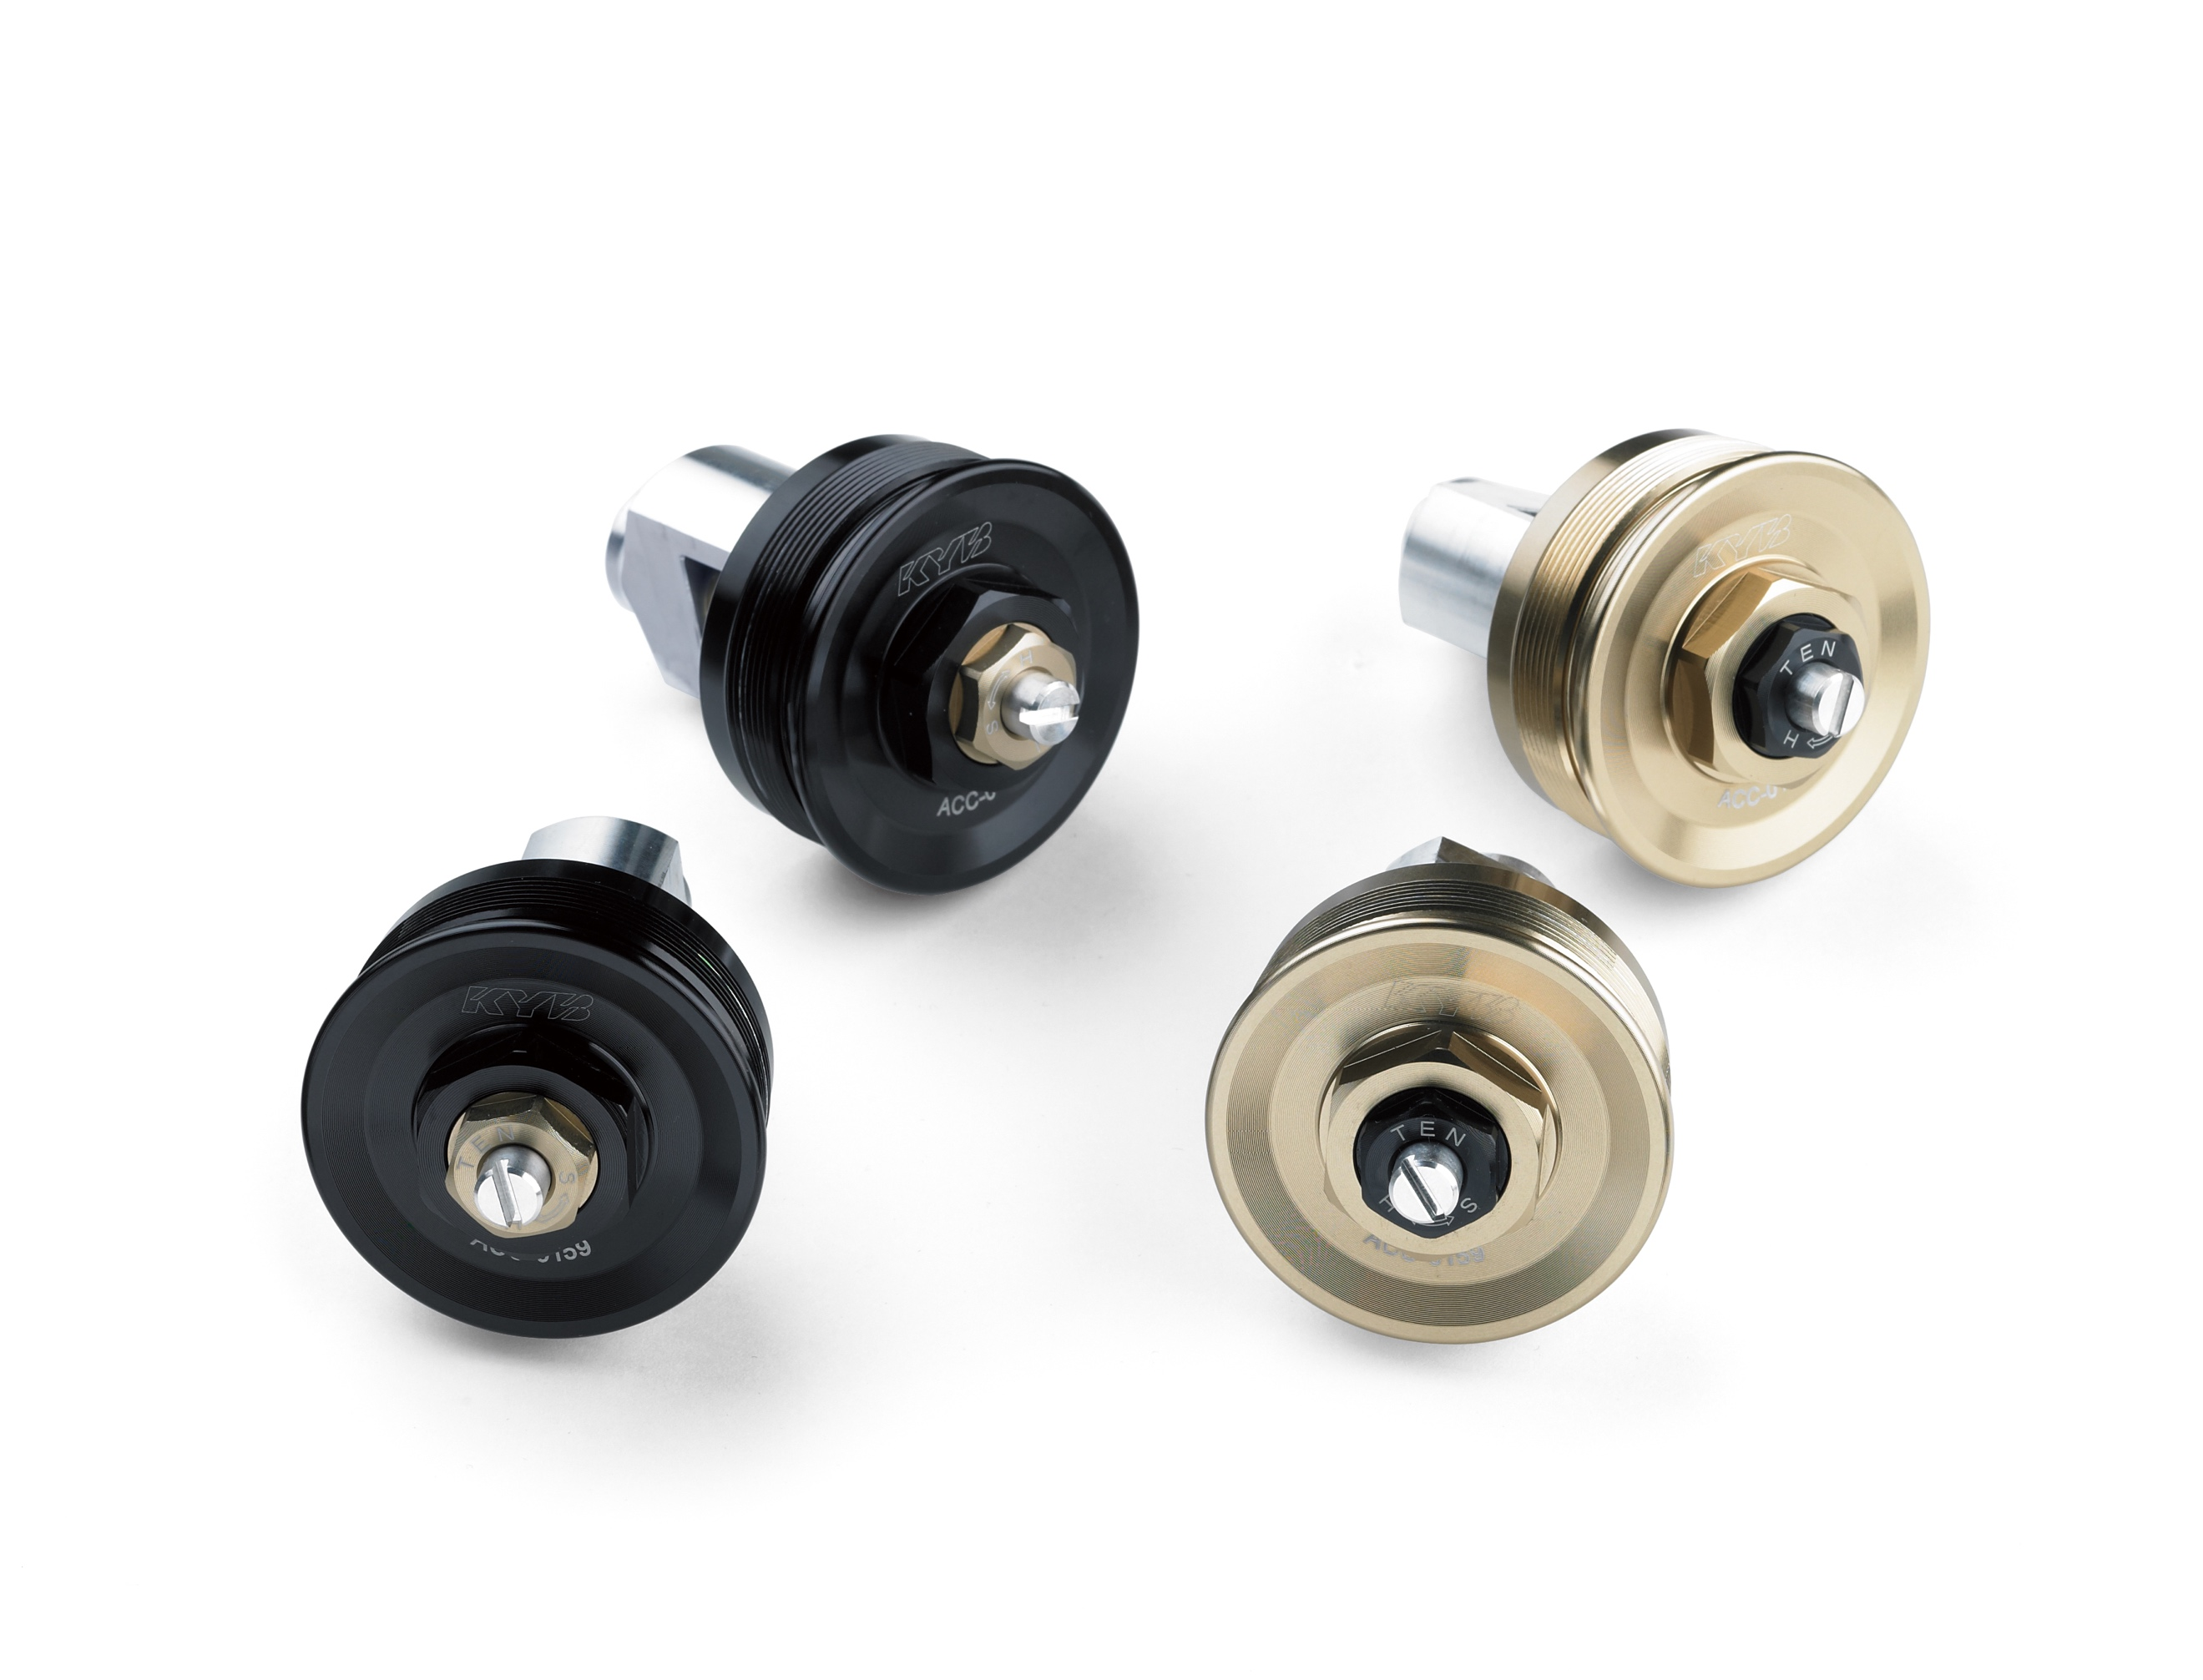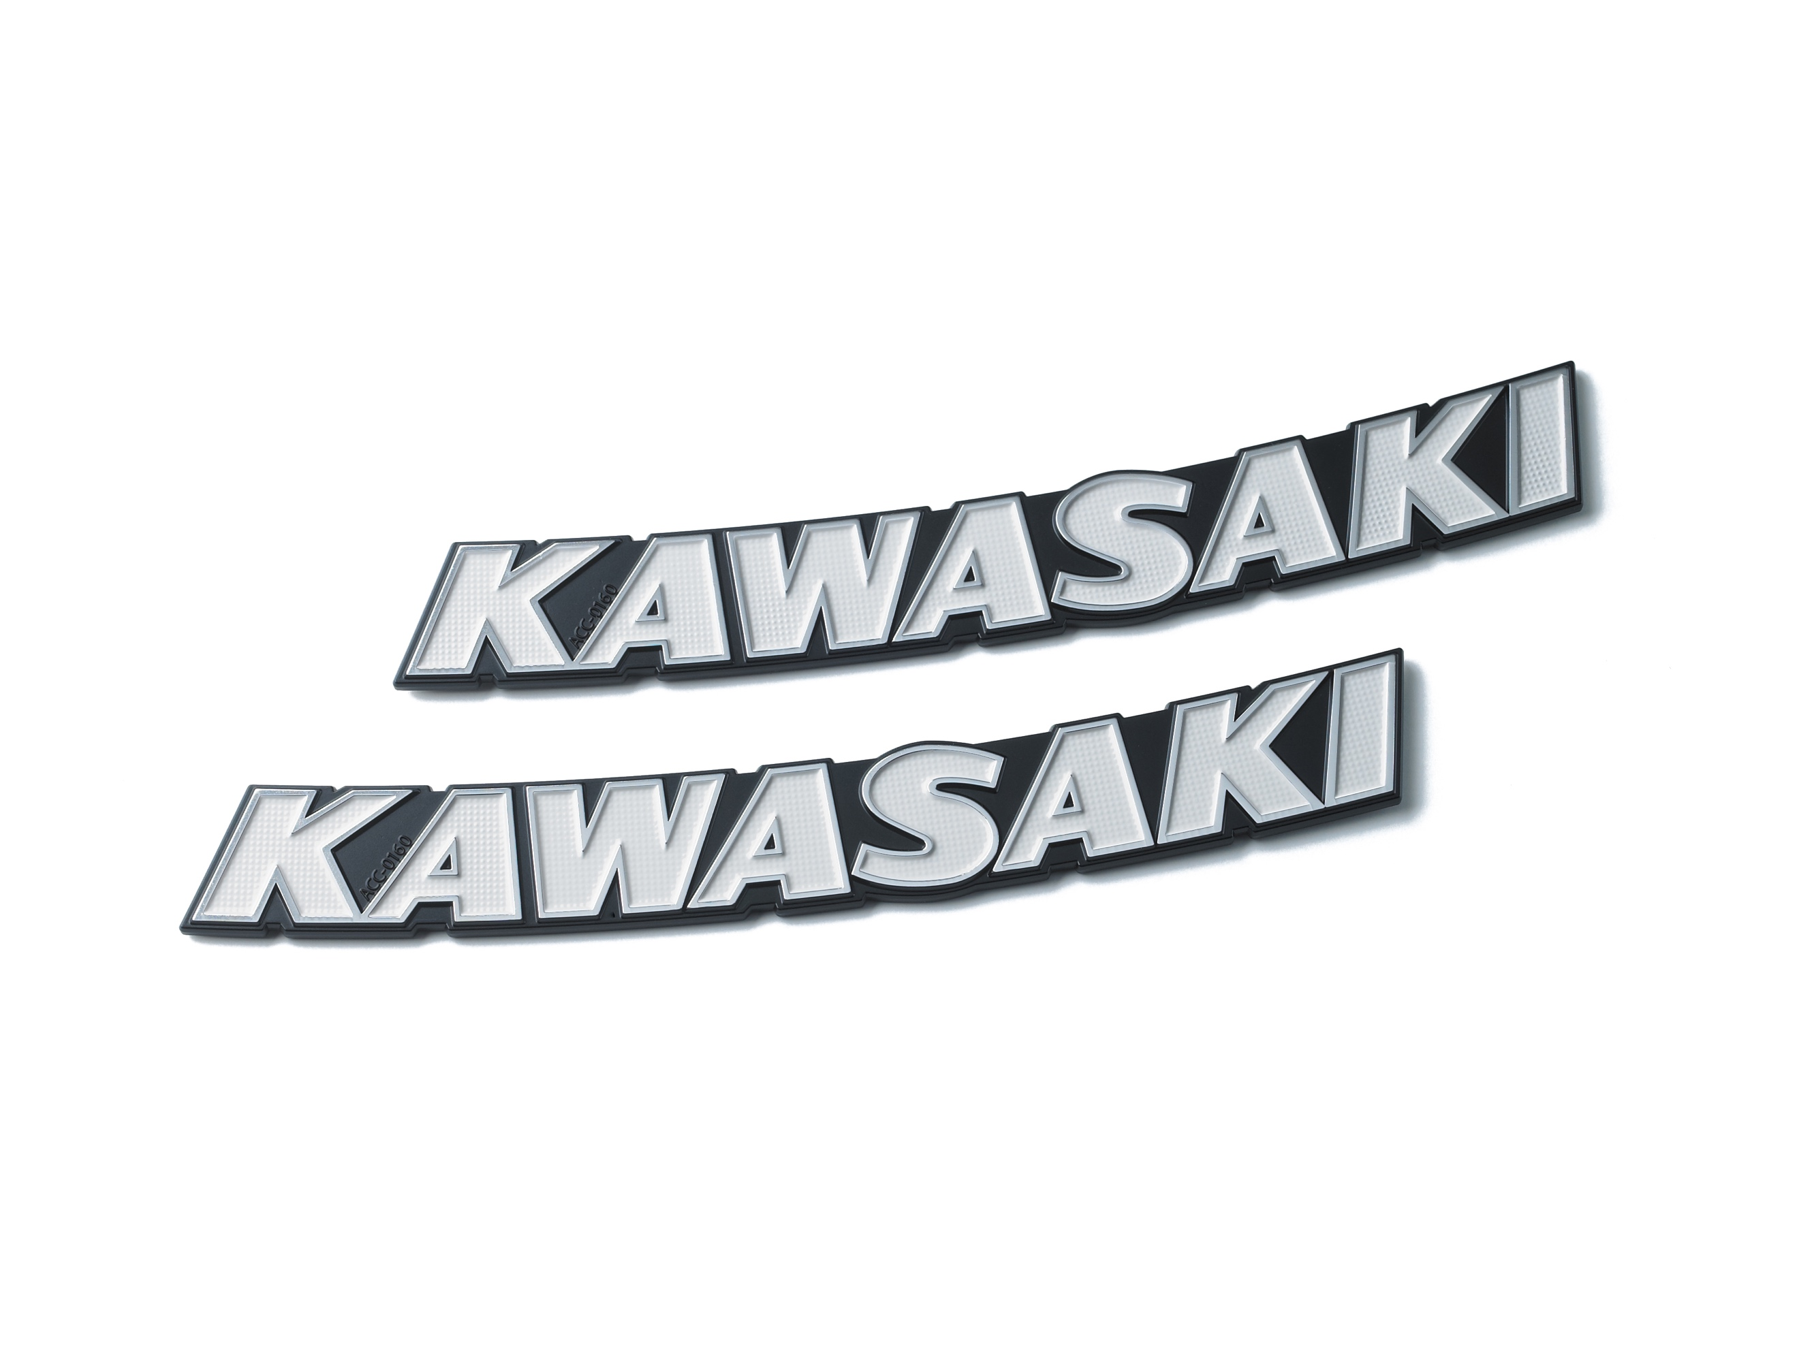

ABOUT KAWASAKI
Kawasaki Heavy Industries, Ltd. (KHI) started full-scale production of motorcycles over a half century ago. The first Kawasaki motorcycle engine was designed based on technical know-how garnered from the development and production of aircraft engines, and Kawasaki’s entry into the motorcycle industry was driven by the company’s constant effort to develop new technologies.
Numerous new Kawasaki models introduced over the years have helped shape the market, and in the process have created enduring legends based on their unique engineering, power, design and riding pleasure. In the future, Kawasaki's commitment to maintaining and furthering these strengths will surely give birth to new legends.
Kawasaki Motors (Malaysia) Sdn. Bhd. (KMSB) is the Franchise Holder and Sole Importer, Assembler, Distributor for Kawasaki Motorcycles, Jet Skis, ATV, Mule, RUV, Power Products, Spare Parts and Accessories for Malaysia and Brunei Darussalam.

We have a well-established network of premium dealers and stockist to market and to promote our products to our customers. The Kawasaki Exclusive Service Center (KESC) and Kawasaki Pitstop (KPS) network, quality assurance and supported with fully equipped Service Centre, well-stocked Spare Part Centre strategically located all over the country to meet our customers' demand.

It is the company's philosophy to attain the highest standards in all its undertakings. Our passion for excellence, supported with dynamic and committed workforce gives us the best opportunity to achieve high standards and quality products, and services to offer to our customers, dealers, business associates and stakeholders.

