THE NEW LEXUS LS 500

OVERVIEW
The Lexus LS was the first model introduced by the new premium brand in 1989. As the flagship of the Lexus range, the LS has always been a technological leader as well as setting and raising benchmarks in its class. Craftsmanship and refinement have been hallmarks of the LS as well as other Lexus models, complemented by the superlative experience offered to owners.

Every LS is produced at the Lexus factory in Tahara, Japan, by only the most skilled personnel. Since 1989, four generations of the LS have been introduced; each designed to exceed the expectations of customers. Although initially developed with the American market in mind, the LS has since become a global model sold in 90 countries.

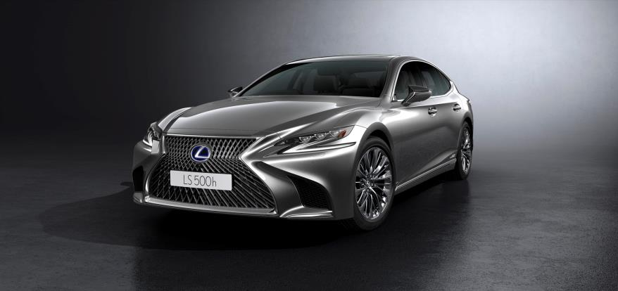

The fifth and latest generation was introduced at the 2017 North American International Auto Show, after having been ‘previewed’ as the LF-FC concept two years earlier. The new model was developed with the objective of exceeding expectations by delivering a new level of flagship luxury in every aspect. To achieve this, the Lexus team started totally from scratch – reimagining what a flagship sedan should be, as if launching the brand all over again.

Like the LC 500 coupe, the latest LS sits on the GA-L (Global Architecture―Luxury) platform which will be used for all rear-wheel drive models in coming years. The GA-L platform is the stiffest in Lexus history, setting the stage for enhanced handling, ride smoothness and cabin quietness.

For the Malaysian market, three variants of the LS are available – the LS 500 Luxury, LS 500 Executive and LS 500h Executive with a Lexus Hybrid Drive. Customers have a choice of up to 11 exterior colours and 6 interior colours/trims (depending on variant).

The innovative paint finishes include two new colours specifically to showcase the bodylines. Manganese Luster adds a highly reflective layer of paint on a base coat with muted brightness as a way of highlighting the shine and expressing a dramatic play of bright and dark, light and shadow. Sonic Agate is a passionate red, but with a deep, rich tone that also expresses dignity and prestige.

EXTERIOR DESIGN
In a departure from the more formal designs of previous generations, the latest LS 500 takes on a more Sensual Aggressive appearance which has sporty undertones. The dramatic and bold look is fronted by a unique mesh grille that uses the signature spindle design.

Evolving from the Human Centre Silhouette concept, the Spindle Architecture is a three-dimensional construction originating at the spindle grille. Ultra-compact 3-beam headlamps flank the front end, with Bi-LED beams providing strong illumination. The turn signals communicate the driver’s intentions by sequential flashing, while providing a visual signature for the model.
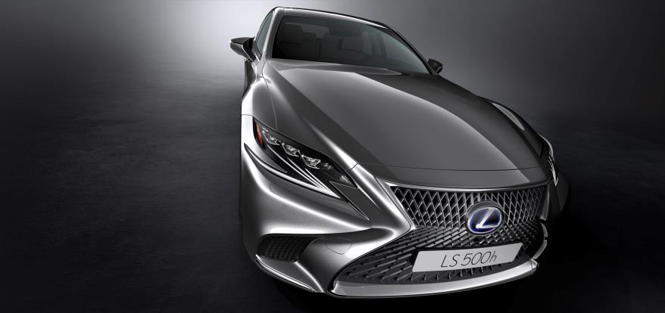
The GA-L platform's low centre of gravity places the sleek silhouette lower and gives the impression of hugging the ground, pursuing aggressive appeal. Additionally, the axes of the powerfully flared front and rear fenders are slanted forwards, creating a dynamic impression that evokes driving performance. This gives contrast to the overall design, combining elements of both static potential and dynamic movement to create a presence befitting a flagship sedan.
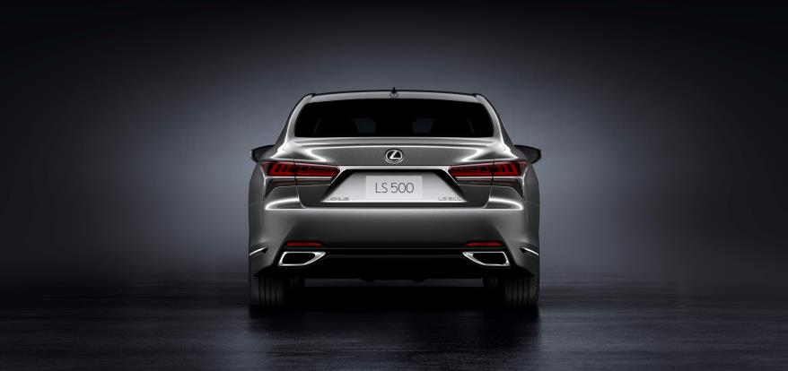
Viewed from the rear, the sleek design makes the body look longer than the actual dimensions. The full LED combination lamps include distinctive turn signal lamps with sequential illumination when activated. Dimensionally, the new LS has gained 28 mm in overall length with a body length that is now 3.125 metres. The wheelbase has also been stretched by 35 mm, giving the model a generous space between the wheels that is comparable to a long-wheelbase limousine. The overall width has been increased to 1.9 metres, 25 mm more than before while the roofline has been lowered by 15 mm.

STRUCTURE
The all-new GA‑L vehicle architecture Is the result of a completely new approach to engineering, materials and loads of the car’s structure. Rather than starting from existing platform and then figuring out how to modify it to fit the new LS and strengthen it to support contemporary chassis dynamics, Lexus engineers literally started with a clean sheet of paper – or more correctly, a blank CAD screen– in designing the new structure.
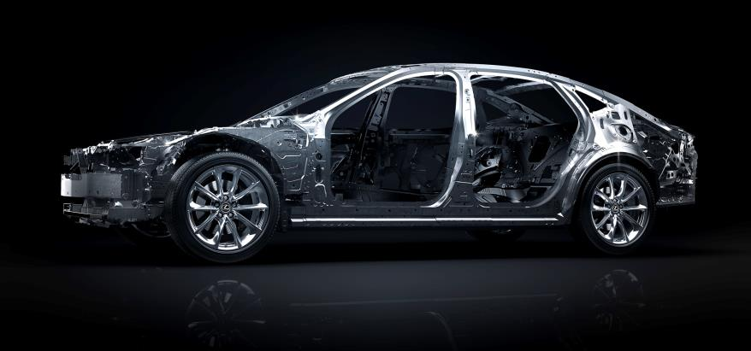
Examples of this can be easily seen under the bonnet where there are new cast-aluminium suspension towers that support the upper spring seats and suspension mounts above each front wheel. Since aluminium and steel can’t be welded together with conventional techniques, the joint attaching the aluminium tower casting to the steel body structure is made with self-piercing rivets and high-strength adhesive bonding; similar processes are used to secure the aluminium rear suspension towers to the body structure behind the back seats.

Compared to structures with similar capabilities in steel, this technology is 42% lighter at the front; in the rear the aluminium structure has 1.5 times the rigidity of steel with 50% less weight. In creating the new LS, engineers used lightweight materials including ultra-high tensile hot stamped steel and other steel alloys in critical areas with higher tensile strengths and aluminium. In fact, the new LS has a high tensile steel mass composition of nearly 30%, which is more than double what was present in the previous generation.
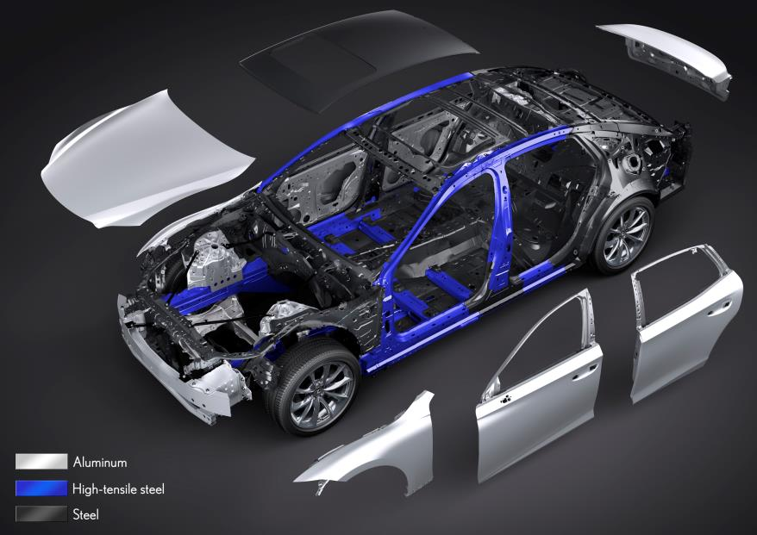 | A combination of special body adhesive and the use of Laser Screw Welding, a proprietary laser welding process proven on other recent Lexus models, increases panel joint rigidity and gives the LS a feeling of exceptional strength and solidity. Critical to its driving performance, the new platform lowers the centre of gravity by placing most of its mass, including the engine and the occupants in positions more centralized and lower in the chassis.
Special braces in the engine compartment, stiff aluminium front and rear suspension towers, and other features help bolster the strength of key chassis structures.

INTERIOR
Following the “Yet” philosophy that has been passed on since the first-generation LS, Lexus created a design offering the room and comfort of a prestige three-box sedan. The new LS is also the first Lexus sedan with a six-window profile, which enables excellent outward visibility. Also a first for a Lexus sedan, the flush-surface windows smoothly integrate with the side pillar.
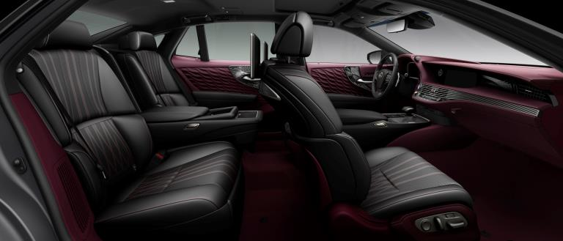
But creating a new standard of flagship luxury is not simply a matter of adding more features and technology. Inspired by the omotenashi principle, the new LS cabin has a luxurious ambience that welcomes and envelopes passengers while treating the driver like a partner.

Lighting and attention to detail express a unique aesthetic in the LS. A new approach to creating trim elements again turned to Japanese culture, combining traditional Japanese aesthetic with advanced manufacturing techniques. This is reflected in signature touches, such as beautiful interior ambient lighting inspired by Japanese lanterns and armrests that appear to float next to the door panel.

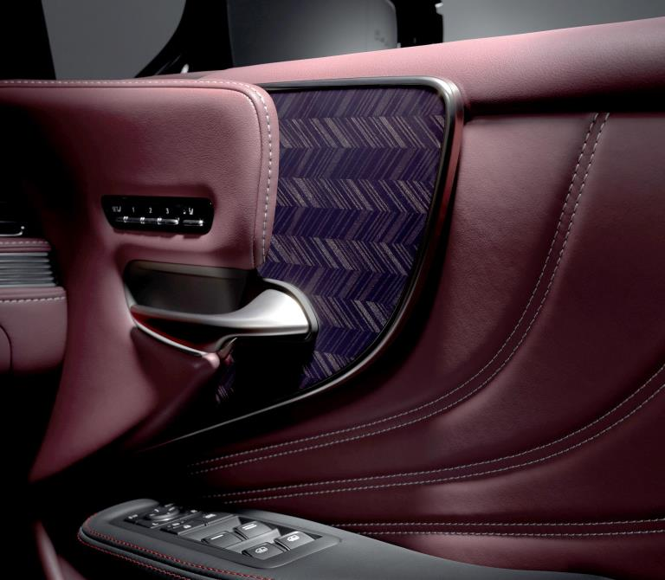 | Inspired by Shimamoku wood patterns, the new forms that combine the artistic combination of natural woodwork and application of Japan’s sophisticated sliced wood and laser cutting manufacturing technologies can be seen in the new LS. New patterns include Art Wood/Organic and Art Wood/Herringbone.  Compared to the straight-grain Shimamoku pattern, the new LS cross-grain is a larger pattern featuring bolder contrasts between light and dark, giving the wood a more vibrant appearance.
New seating designs include front seats that are power-adjustable up to 28 ways and 22 ways for the rear seats. Combining electric motors with a new pneumatic control system allows fine adjustment of the entire seat with minimal weight and bulk while heating and massage are included. A Warming Function (spot heater) in the rear seat is a world first. Two dedicated heaters—located in the shoulder and lower back areas of the seat—warm these specific areas without warming a person’s entire body.
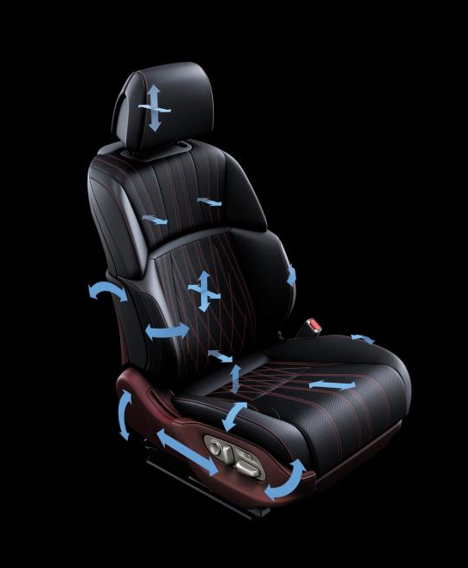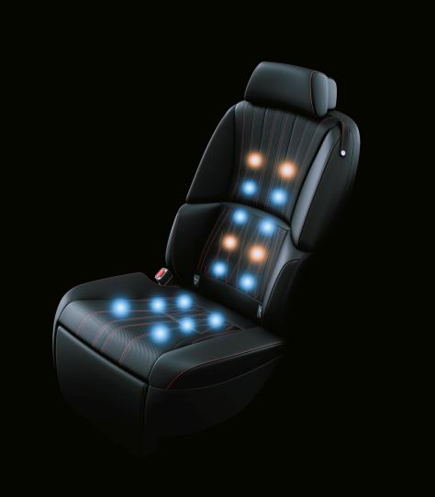
The optional Kiriko Glass ornamentation and hand-folded pleats on the door trim perfectly illustrate the brand’s ‘Innovative elegance through Japanese craftsmanship’ and exemplify a true handcrafted approach. The striking cut glass ornamentation – a world first in a production vehicle - draws inspiration from Japanese Kiriko glassware.

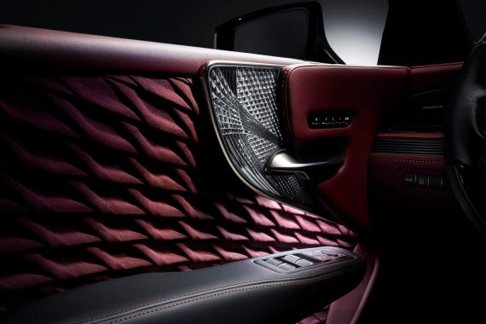 | Traditional Kiriko patterns are created using a technique that involves hand-cutting clear colours and delicate lines in a piece of glass, which are then repeatedly polished to a soft glow. For the LS, Kiriko master craftsmen worked closely with Lexus designers and engineers to duplicate the hand-carved appearance of Kiriko cut glass using leading-edge laser data copying and polishing technology.

The Hand-pleated Upholstery is produced using a process that took 4 years to develop—and that can be done only by human hands. A single cloth sheet is folded like origami paper, each fold carefully overlapped with the next, creating a dramatic pleated effect. The effect of the light and the three-dimensional upholstery creates an elegant space that envelops the occupants. Due to the complexity of producing the Kiriko Glass ornamentation and Hand-Pleated upholstery, availability is limited for each market and is exclusive to LS500 and LS500h Executive variants.
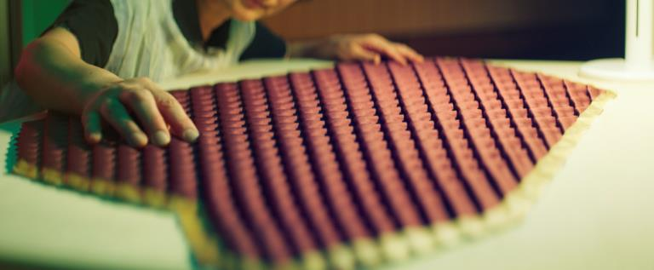

Integrated into the LS 500’s cabin is the next-generation Remote Touch Interface, designed to mimic smartphone operation and supporting handwritten input. In addition to its 12.3-inch wide navigation display, the LS can incorporate a 24-inch colour heads-up display (HUD)—the largest in the world—that projects a variety of information onto the driver’s forward view.
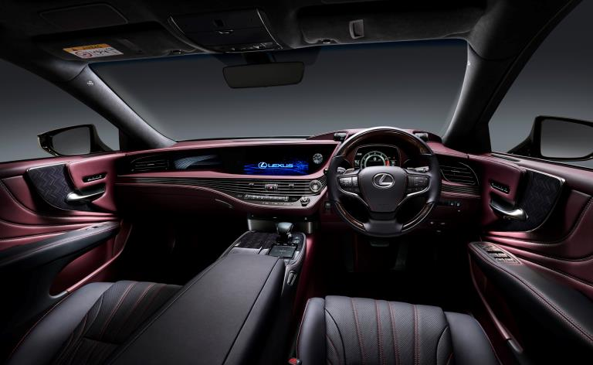
While making the new LS even more of a driver’s car, Lexus also optimized the LS as a car in which to be driven, lavishing considerable attention to the two occupants in the rear seat. The rear cabin design creates seamless, enveloping continuity between the trim and seatbacks for passenger egress.

With the Executive variant that includes an Ottoman, there is more legroom than any previous-generation LS. In addition, the seat behind the front passenger can be power-reclined up to 48 degrees and can be raised up to 24 degrees to assist the rear-seat passenger exiting the vehicle.
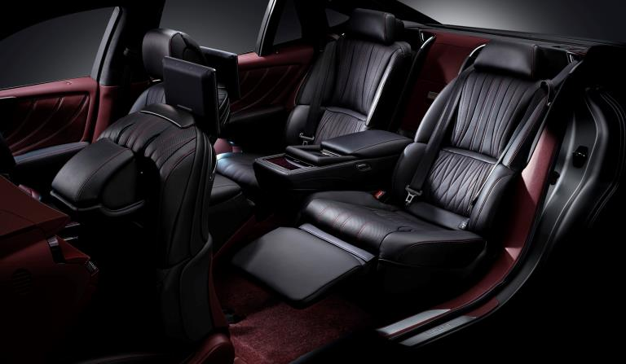
Because the new LS is lower than previous models, its air suspension system has an access function to make getting in and out easier. Activated by unlocking the car with the smart key, access mode automatically raises the car by 30 mm and widens the seat bolsters to welcome drivers behind the wheel.

Ensuring comfort at all time, the Lexus Climate Concierge conducts integrated control of heating and cooling by detecting the body temperatures of each occupant. It uses infrared sensors that measure body surface temperatures in the front and rear seats to provide the most-comfortable interior climate conditions for each occupant.
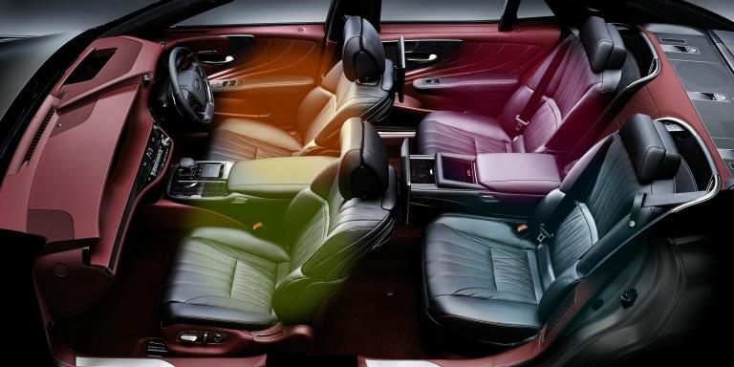
The exhaust sound has been tuned to convey a more authoritative tone but within the cabin, there is quietness that will be hard to believe. New sound suppression methods have lowered exterior noise far more significantly than all previous LS models. With Active Noise Control, noise levels within the cabin are lowered by detecting the sound of the engine coming into the vehicle and cancelling certain frequencies using antiphase sound from the audio speakers.

Mark Levinson has long worked with Lexus to provide custom-designed audio systems that are among the best in the world for cars. For the latest LS, there is 3D surround with the Mark Levinson QLI Reference Surround Sound System. Employing Quantum Logic Immersion technology (QLI), Clari-Fi music restoration technology and 23 speakers in 16 locations throughout the car (rear ceiling included), and a 16-channel Mark Levinson Reference Amplifier producing the equivalent of 2400watts with 0.05percent Total Harmonic Distortion (THD), it offers an unparalleled audio experience.
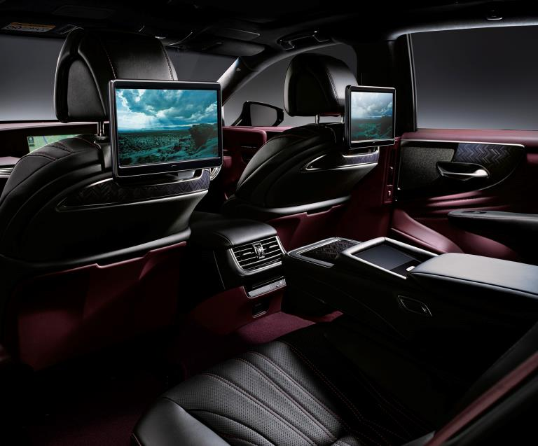
Occupants in the rear seats of the LS 500 Executive each have an 11.6-inch 720p LCD display on the headrest in front of them. The system can play DVDs and Blu-Ray discs as well as connect to portable devices via HDMI ports in the armrest. It also supports DLNA and Miracast via wifi.

POWERTRAINS
This generation of the LS sees an all-new 3.5-litre V6 engine specifically developed for the model. This engine has an undersquare design for improved thermal efficiency coupled with twin turbochargers, and has benefitted from the company’s technology developed for F1 racing. This new LS engine is indicative of the more dynamic approach being taken by Lexus, offering V8-level power in a more compact package with efficiency and refinement.
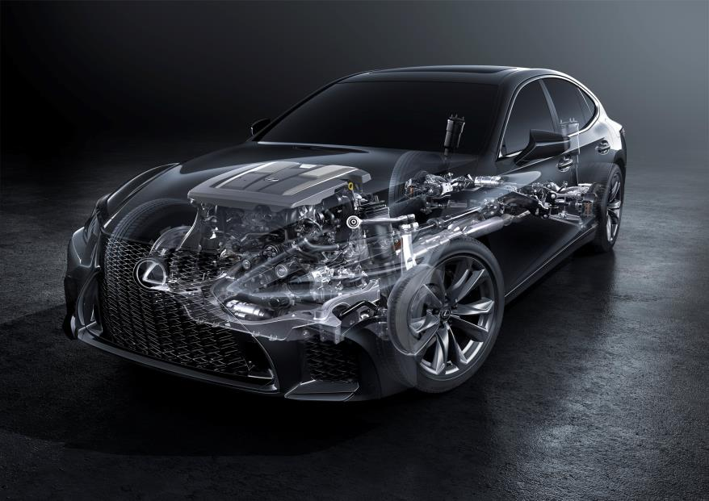
The new LS engine offers the output one would expect in a flagship sedan: 310 kW/415 hp with 600 Nm of torque, significantly higher than the previous naturally aspirated 4.6-litre V8 engine. The engine’s long stroke, optimized bore-to-stroke ratio, increased valve angle, straight intake ports and laser-clad intake valve seats developed using performance simulations based on F1 technology combine to yield world top-level high-speed combustion technology and thermal efficiency.

The twin turbochargers were designed and produced in-house to control tolerances and quality. They achieve top-level mechanical efficiency by improving exhaust energy recovery using a curved turbine blade shape and increased blade length, along with die-cast compressor housings and improved surface precision. Electric wastegates provide ultra-precise turbo boost control for seamless, lag-free power build-up. The intercoolers are cooled by engine coolant for higher performance and efficiency.

A special version of Lexus’ D4S direct injection system with port injection was developed to improve injection control linked to turbocharger operation. Called D 4ST, this system controls new 6-hole direct injectors and the port fuel injectors to take advantage of the turbochargers and the high tumble ratio of the engine.

Twin water-to-air intercoolers reduce the temperature of air pressurized by turbocharging. The intercoolers are mounted on top of the engine, each in a direct path between its turbocharger and intake throttle to reduce volume and lag in the intake tract.

Remarkable powertrain smoothness, a Lexus hallmark, begins deep inside the cylinder block, where a ladder frame support for the crankshaft main bearings adds rigidity for low vibration. Redesigned engine mounts, the electric wastegates and numerous other features also contribute to the engine’s ultra-smoothness.

The first-ever 10-speed automatic transmission for a premium passenger car, having debuted in the LC 500, is now also used in the new LS 500. It is a torque converter automatic, yet with shift times that rival those of dual-clutch transmissions. The wide bandwidth afforded by 10 closely-spaced ratios is ideal for all driving situations.

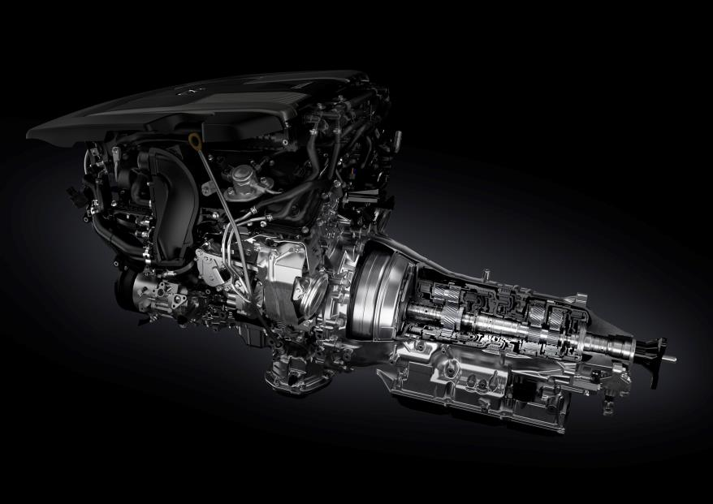 | Using aluminium for the clutch drum, clutch hub and planetary carrier reduce rotating mass; coupled with shortened internal oil passages and smaller, faster shift solenoids results in quicker shifts. These improvements, plus a resin plastic transmission oil pan, yield a 10-speed transmission that is about the same physical size as the previous 8-speed gearbox. The LS features steering wheel shifter paddles and even drivers who might enjoy controlling gearshifts manually will be duly impressed by the automatic mode’s advanced electronic control system.

The artificial intelligence transmission logic (AI-Shift Control) anticipates the driver’s input by monitoring acceleration, braking and lateral-g forces to execute perfectly timed, and ultra-quick shifts.

For starting acceleration, the close ratios of the low gears and the short shift times enable a rhythmical and exhilarating acceleration feel. The high torque of the twin-turbo engine matches ideally with the higher gear ratios for effortless highway cruising, yet very quick downshifts yield direct acceleration with no lag in G response. To provide a direct feel, while also supporting fuel efficiency, torque converter lock-up activates in all ranges except when starting off.

CHASSIS
The GA‑L platform is the stiffest in Lexus history, setting the stage for enhanced handling and ride smoothness. The new wide and low design optimizes the centre of gravity and weight distribution. Helping to provide handling balance is the latest generation of a chassis control technology, Vehicle Dynamics Integrated Management (VDIM). This system implements cooperative control of all available vehicle subsystems – ABS, Traction Control (TRAC/TRC), Vehicle Stability Control (VSC), Electric Power Steering (EPS), to control basic longitudinal, lateral and vertical motion as well as yaw, roll and pitch.

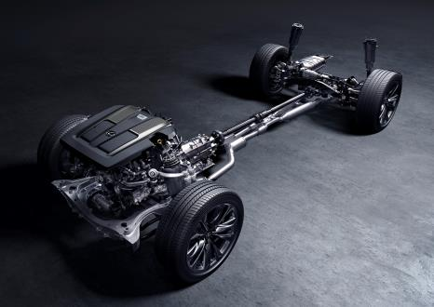 | Both the front and rear suspension have multi-link layouts for optimum wheel location under all cornering and surface conditions. The front suspension has double ball joints on the upper and lower arms which are evolved versions of the ones found in the LC 500. For the rear, the suspension components have been packaged compactly in spite of the multi-link configuration. Adaptive Variable Suspension (AVS) provides superior ride and handling, with the same quality as that of the LC 500.
Sensors monitor the car’s motion in every direction and adjust the suspension settings to optimise handling and comfort. The linear solenoid actuator can provide up to 650 different damping forces, adjusting instantaneously according to conditions detected by the sensors. As a flagship model, the LS must offer the best ride possible and the use of Air Suspension enables exceptional ride quality. Electronically controlled, the system has quick operation and draws on stored compressed air for immediate activation.

SAFETY SYSTEMS
As the flagship of the Lexus range, the LS has always been at the forefront of safety technologies, often being the first in the world with advanced new technologies. The latest LS continues its leadership in this aspect with the Lexus Safety System+ that is ultimately aimed at reducing traffic fatalities. The Lexus Safety System+ a Pre-Collision system (PCS), Lane Departure Alert, Adaptive Cruise Control, Lane Departure Alert, Adaptive High-Beam System and Lane Keep Assist.
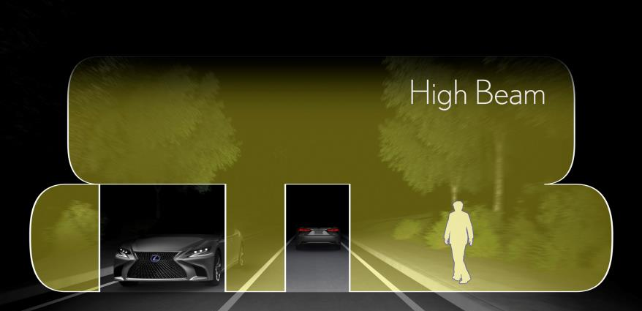
The new LS further benefits from additional active safety technologies that help protect the car and occupants by alerting the driver to collision risks when parking and providing a view of the area immediately around the vehicle when manoeuvring or cornering. These systems are the Panoramic View Monitor and Blind Spot Monitor, both of which display imagery on the large full-colour screen on the dashboard.
While the occupants are given additional protection by up to 12 SRS airbags, which include side and seat cushion airbags at the rear, the protection of pedestrians has also been taken into consideration. Lexus engineers have designed special sensors installed in the front end which detect impact with a pedestrian. Upon detection, a mechanism will pop up the bonnet to create extra space over the engine, increasing the cushioning effect so as to reduce injuries to the pedestrian.

-ENDS-

