The new Audi Q5 – Now is calling

- Latest generation of the best-top selling model from Audi, made even more powerful and flexible
- Benchmark premium SUV that strikes the ideal balance of sportiness, sophistication and progressiveness
- Now available, the Audi Q5 2.0 TFSI quattro is priced at RM 339,900

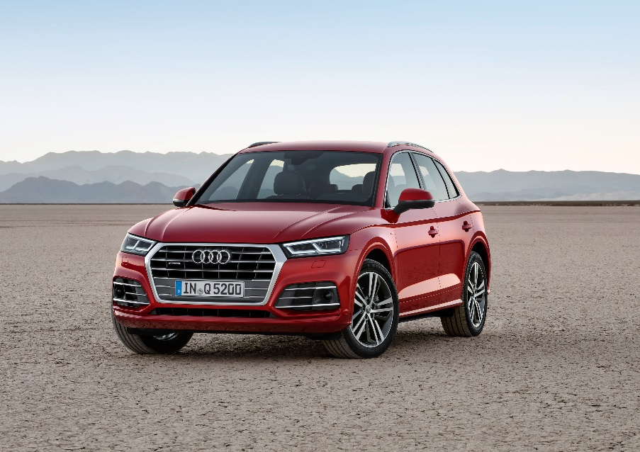
The all-new Audi Q5

MALAYSIA, MARCH 4, 2019 – Audi presents another successful model: The SUV with the four rings combines the sportiness of an Audi sedan with a multifaceted character and a highly flexible interior. Whether in its connectivity, efficiency or driver assistance systems – the new Audi Q5 once again sets standards in its segment.

The new SUV from Audi takes a sporty and taut stance on the street. A sculpturally flared Singleframe grille with a solid frame dominates its aerodynamically flat front end.

Typically Audi: Reference to the quattro drive
A distinctively curved and strongly undercut shoulder line gives structure to the side view. The strongly emphasized wheel arches are a reference to the quattro permanent all-wheel drive system, and the low greenhouse tapers back down early. Just as at the front, horizontal lines at the rear convey an image of width and presence. The tail lights are also available with optional dynamic turn signals. The tailgate wraps around the C-pillars – a typical feature of the Q models from Audi. A diffuser insert integrates the exhaust tailpipes.

Weight saved: up to 90 kg lighter than the previous model
4.66 meters long, 1.89 meters wide and 1.66 meters tall with a 2.82 meter wheelbase – compared to the previous model, the new Q5 has grown in nearly all of its dimensions. Consequently, the unladen weight was reduced – depending on the engine – by up to 90 kg. Steels with maximum tensile strength and aluminum form an intelligent material mix in the body.

The new Q5 also stands at the top of its class in its aerodynamics. The four cylinder versions attain a cd figure of 0.30 with the aerodynamically optimized roof. Wind noises are exceptionally low, and vibration comfort is high – the new SUV from Audi indulges the driver and passengers with the best interior acoustics in its class.

Spacious and wide: the interior
The interior offers a lot of space for five persons, and it surpasses the previous model and its competitors in key dimensions. Its horizontally oriented lines underscore the impression of width and comfort, and a three-dimensional trim strip runs across the entire width of the instrument panel. The customers are offered a broad selection of colors and materials.

Three-spoke multifunction steering wheel with shift paddles is standard. When it is dark, the ambient lighting creates an attractive atmosphere in 30 different colors. The workmanship quality in the new Q5 is uncompromising.

The rear seat back of the new Audi Q5 is split into three segments. Depending on the rear seat position, the basic volume of the luggage compartment ranges from 550 to 610 liters, 10 liters more than in the previous model. When the rear bench is folded down, this volume grows to 1,550 liters. Cargo loading is simplified by intelligent solutions like a standard, variably folding mat, sensor control of the power tailgate and manual lowering of the body via the optional air suspension.

Simply coherent: controls and displays
Operation of the new Audi SUV is intuitive and is marked by three great new features. The Audi virtual cockpit (standard for Malaysia) presents brilliant graphics on its high-resolution 12.3-inch screen. The driver can choose from two views – a classic view with large round instruments and a mode in which the navigation map or lists dominate. The also optional head-up display projects key information onto the windshield.

The MMI terminal in the center console acts as the main control element. The MMI navigation plus with MMI touch and an 8.3-inch display, a large MMI all-in-one MMI touchpad with haptic feedback is integrated into the rotary pushbutton. It recognizes handwritten entries as well as gestures familiar from consumer electronics such as zooming gestures.

The MMI operating logic is based on the flat hierarchies used in today’s smartphones, and it offers such features as intelligent free-text search. The new natural-language voice control function also recognizes inputs from everyday speech. Serving as an additional third operating level in the new Audi Q5 is the multifunction steering wheel plus. Audi can deliver a newly developed head-up display as an option. It projects relevant information onto the windshield – including from driver assistance systems – as symbols and numbers that can be perceived quickly.

Audi navigation: “Personal route assist”
The new Audi Q5, like the Q7 and the A4, has a self-learning “personal route assist” function. After activating this function, the navigation system learns the routes and destinations that the customer regularly selects, and it associates this information to the parked position and time of day.

For as long as it is active, the system therefore learns from the customer’s behavior and uses this information to suggest optimized route planning for the next trip – even while navigation is inactive. The navigation system incorporates the three most likely destinations into the calculation, taking into consideration both the arrival time and current traffic levels. For instance, the system can suggest that the customer activate navigation to find out about potential alternative routes. The driver decides whether or not to activate the function. He also has the option of deleting saved destinations.

If the function is deactivated, the system does not store the destinations and does not consider deleted destinations or the routes driven.

Versatile and efficient: drivetrain
The new quattro drivetrain with ultra technology is standard equipment for the 2.0 TFSI* with 185 kW (252 hp)*. The quattro with ultra technology always disengages the rear-axle drive whenever it is not needed, and if necessary it can proactively re-engage it. The new concept boosts efficiency without reducing traction or driving dynamics.

Wheel-selective torque control is standard for the Malaysia specific Audi Q5. The system gives handling a refined touch. The intelligent software solution always delivers a dynamic, precise and controllable driving experience.

Resolving contradictions: the chassis
The new Audi Q5 enables handling that combines very different strengths – it is sporty while being extremely comfortable. Creating the basis for this are the newly developed five-link suspensions and also the new electromechanical power steering system.

The chassis with damper control, which is standard for Malaysia, offers a very wide spread between comfort and dynamics, which the driver can select via Audi drive select. In addition to adjusting damper control, the new optional adaptive air suspension can be used to vary the ride height of the car body over five stages.

In the standard system, Audi drive select, which accesses various technical modules, the driver can select one of as many as seven driving modes. The two new modes, lift/offroad and allroad, emphasize the offroad character of the Audi Q5 optimally.

The new Audi SUV comes from the factory with 19-inch alloy wheels as standard for Malaysia.

For more information on the brand and various car models from Audi Malaysia, visit their official website at http://www.audi.com.my/sea/web/my.html

– End –

Fuel consumption of the models named above:

Audi Q5 2.0 TFSI (185 kW/252 hp)
Combined fuel consumption in l/100 km: 7.1 – 6.8
Combined CO2 emissions in g/km: 162 – 154

* Fuel consumption and CO2 emissions figures given by based on the standard version offered in Malaysia.

The Audi Group, with its brands Audi, Ducati and Lamborghini, is one of the most successful manufacturers of automobiles and motorcycles in the premium segment. It is present in more than 100 markets worldwide and produces at 16 locations in twelve countries. 100 percent subsidiaries of AUDI AG include Audi Sport GmbH (Neckarsulm), Automobili Lamborghini S.p.A. (Sant’Agata Bolognese, Italy) and Ducati Motor Holding S.p.A. (Bologna, Italy).

In 2017, the Audi Group delivered to customers about 1.878 million automobiles of the Audi brand, 3,815 sports cars of the Lamborghini brand and 55,900 motorcycles of the Ducati brand. In the 2017 fiscal year, AUDI AG achieved total revenue of €60.1 billion and an operating profit of €5.1 billion. At present, approximately 90,000 people work for the company all over the world, more than 60,000 of them in Germany. Audi focuses on sustainable products and technologies for the future of mobility.

