The new Audi Q7: The great quattro

- A statement of the high-tech competence of Audi: The most efficient and lightest car in its class
- Luxurious comfort, the largest interior in the segment, innovative assistance and infotainment systems take the large SUV to the front of the pack
- Now available, the Audi Q7 3.0 TFSI quattro is priced at RM 599,900

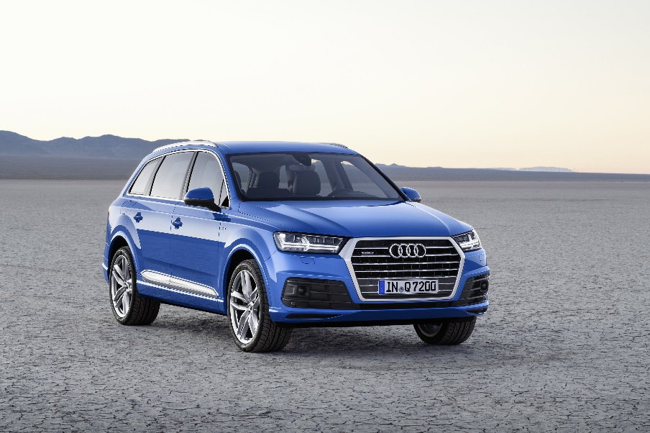
The all-new Audi Q7

MALAYSIA, MARCH 4, 2019 – Luxurious comfort, the largest interior in the segment and a weight saving of up to 350 kilograms – the Q7* from Audi sets new standards. Its innovative assistance and infotainment systems take the large SUV to the front of the pack. Its new engines consume significantly less fuel than the previous model.

Up to 325 kilograms less weight
Thanks to the strict lightweight concept from Audi, the basic version of the new Q7 remains under two tons unladen (without driver) – up to 325 kilograms lighter than the predecessor model, depending on the engine version. The body alone with its innovative multi-material construction saves 71 kg in weight, with add-on parts (aluminum doors), 95 kg. With 5.05 meters in length, 1.97 meters in width and 1.74 meters in height (with steel suspension), the new Q7 is a big car – but also the lightest in its class.

Handling dynamics: The interplay of all components
The sporty handling dynamics unusual for an SUV results from the close coordination between all departments within technical development. The engines harmoniously deliver their power to the road practically loss-free via a superior chassis. This interplay of components provides the ideal basis for dynamic handling. Given also the quattro drive, a quick-shifting tiptronic and the low overall weight, each trip, whether on the freeway or a winding country road, brings the dynamic handling of a sedan to mind. Meanwhile the developers never neglected the need for a stable driving style off paved roads, or the desired dynamic gear mode – the Audi Q7 performs impressively on any terrain.

Lounge of the luxury class: The most spacious interior in the segment
On opening the door, the driver encounters a lounge of the luxury class. All colors and materials are carefully coordinated. In the front passenger area a continuous air vent strip stretches across the instrument panel and emphasizes the width of the interior. Restrained strips frame two-part decorative moldings; in the dark, optional, slender light guides follow the contours of the interior.

For the driver all switches and controls are ideally placed ready at hand. The numerous setting options afford a very comfortable seat position. The new Q7 offers numerous seat variants up to a customized contour seat with air conditioning and a massage feature. The versatility of the Audi Q7 is also revealed by the standard three-piece backrest in the second row of seats, which can be separately folded down, and by the third row of seats (standard for Malaysia), which is now operated electrically. Also standard for Malaysia is the Audi virtual cockpit, in addition to the Audi MMI monitor – the 12.3-inch diagonal TFT monitor displays elaborately computed graphics, and is operated at the multifunction steering wheel. In addition, the head-up display can be specified to project key information onto the windshield.

In the seven-seat model the basic configuration of the luggage compartment has the flexibility of altering its capacity from 295 liters to 1,955 liters.

Infotainment with the MMI all-in-touch
On the console of the center tunnel lies the newly developed MMI touch. Driver and front passenger can write, pinch-to-zoom, or scroll through lists on the system’s large glass surface, which gives a haptic response to the operator’s finger. The simple MMI operating logic affords intuitive use, including intelligent free text searching. The voice control system can recognize input made using everyday language, such as: “Where can I refuel?”

The top-of-the-line infotainment system in the Q7, MMI navigation plus, uses the second generation modular infotainment module with its first-class computing power. This is standard for Malaysia. In conjunction with the Audi connect module, passengers can surf the web with mobile devices via an integrated Wi-Fi hotspot. The LTE module also brings the online services of Audi connect on board. Among the many new services in this portfolio, the optional Audi smartphone interface is a particular highlight: It integrates smartphones with iOS and Android technology in a customized environment on the MMI monitor.

Engine: Three-liter TFSI
The new Q7 enters with the 3.0 TFSI with 245 kW (333 hp). It accelerates the large seven-seat SUV from 0 to 100 km/h in 6.3 seconds.

Superior engines, a new eight-speed tiptronic, improved quattro permanent all-wheel drive, a low center of gravity and a completely redesigned lightweight chassis – the technology package of the new Audi Q7 allows drivability that is both agile and comfortable. Its electromechanical power steering and the versatile Audi drive select system are standard features.

Design: Expressive and striking
The large SUV interprets characteristic design features of Audi and the Q family. A sculpturally molded Singleframe grille with a solid frame is the defining element at the front. Intense wheel arches and the shoulder line emphasize the wheels, while the tailgate extends around the D pillars. They’re complemented by new solutions such as inlay strips at the bottom of the doors.

For more information on the brand and various car models from Audi Malaysia, visit their official website at http://www.audi.com.my/sea/web/my.html

– End –

Fuel consumption of the models named above:

Audi Q7 3.0 TFSI quattro tiptronic (245 kW) (seven seats):
Combined fuel consumption in l/100 km: 8.3 – 7.9;
Combined CO2emissions in g/km: 193 – 183

* Fuel consumption and CO2 emissions figures given by based on the standard version offered in Malaysia.

The Audi Group, with its brands Audi, Ducati and Lamborghini, is one of the most successful manufacturers of automobiles and motorcycles in the premium segment. It is present in more than 100 markets worldwide and produces at 16 locations in twelve countries. 100 percent subsidiaries of AUDI AG include Audi Sport GmbH (Neckarsulm), Automobili Lamborghini S.p.A. (Sant’Agata Bolognese, Italy) and Ducati Motor Holding S.p.A. (Bologna, Italy).

In 2017, the Audi Group delivered to customers about 1.878 million automobiles of the Audi brand, 3,815 sports cars of the Lamborghini brand and 55,900 motorcycles of the Ducati brand. In the 2017 fiscal year, AUDI AG achieved total revenue of €60.1 billion and an operating profit of €5.1 billion. At present, approximately 90,000 people work for the company all over the world, more than 60,000 of them in Germany. Audi focuses on sustainable products and technologies for the future of mobility.

