The new face of the Q family: the Audi Q8

- Combines the spaciousness and ergonomics typical of an SUV with the elegant body line of a four-door coupé
- Comprehensively connected and tough enough for off-road duty, it is a composed companion for business and leisure
- Now available, the Audi Q8 3.0 TFSI quattro is priced at RM 727,900

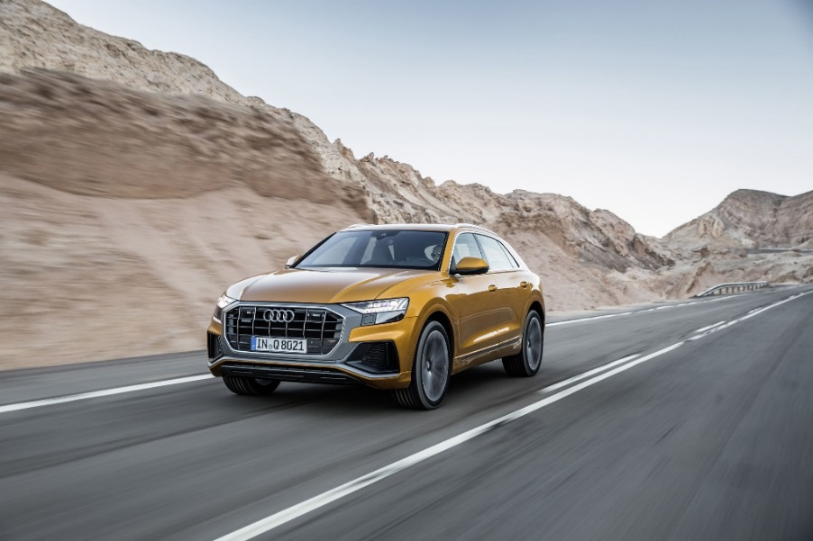
The all-new Audi Q8

MALAYSIA, MARCH 4, 2019 – The Audi Q8 combines the spaciousness and ergonomics typical of an SUV with the elegant body line of a four-door coupé. Richly equipped, comprehensively connected and tough enough for off-road duty, it is a composed companion for business and leisure.

Versatile, sporty, elegant: the dimensional and space concept
The Audi Q8 exudes sporty dynamics and upscale prestige like no other SUV from the brand with the four rings. 4.99 meters long, 2.00 meters wide and 1.71 meters tall, the SUV coupé is wider, shorter and lower than its Q7 sister model. With a wheelbase of nearly 3.00 meters, it offers a spacious interior that beats that of its direct competitors in most relevant dimensions, including interior length and headroom. The three-seat system in the rear can be slid forward and backward as desired. With the seat backrests folded down, the luggage compartment under the power rear hatch holds up to 1,755 liters.

New presence for the Q family: the exterior design
With the imposing Singleframe in octagonal design, the Audi Q8 is the new face of the Q family. The brawny radiator grille stands upright and, together with the spoiler that has been drawn toward the front and the large, highly contoured air inlets, emphasizes the self-confident look. The elegantly sloping roofline terminates in gently inclined D-pillars and rests against the quattro blisters above the wheel arches, which house up to 22-inch wheels. Numerous details echo the design of the Ur-quattro. Strong contours and athletically tight surfaces convey a feeling of power, sophistication and the special dynamics of permanent all-wheel drive. The spoiler, wheel arch trims, door trim strips and diffuser are in a contrasting color, to further emphasize the off-road look.

HD matrix LED headlights as standard for Malaysia. With this feature, both the three-dimensional signature of the daytime running lights and the taillights have a digital character. A light strip connects the units at the rear. As in the Audi Ur-quattro, a black surface underlays this strip.

Sporty driving experience: suspension and drive
With as much as 254 millimeters of ground clearance, short overhangs, quattro permanent all-wheel drive and hill descent control, the Audi Q8 can keep going when paved roads end.

Audi offers the adaptive air suspension with controlled damping as standard for Malaysia. It adjusts the ride height depending on the driving situation and the driver’s preference by as much as 90 millimeters.

The SUV coupé is launched in Malaysia as the Q8 3.0 TFSI quattro. The powerful 3.0 TFSI produces 250 kW (340 hp) and develops 500 Nm of torque. The Audi Q8 accelerates from 0 to 100 km/h in 5.9 seconds on its way to a top speed of 250km/h. A fast and smooth-shifting, eight-speed tiptronic transfers the power to the quattro drivetrain. Further engine versions will follow.

The drive system is particularly efficient thanks to the new mild hybrid technology (MHEV). The 48-volt main electrical system incorporates two important technology modules: a lithium ion battery and a belt alternator starter. During braking, it can recover up to 12 kW of power and feed it back into the battery. The MHEV technology enables long coasting phases with the engine deactivated and a start-stop range that begins at 22 km/h. In customer operation, it reduces consumption by up to 0.7 liters per 100 kilometers.

Clarity is the new premium: the interior
Easy-to-understand symbols stand for the digital precision from Audi and for the high level of integration of architecture and operation. The central element is the top MMI touch response display. With its black-panel look, it almost dissolves into a large, black surface when switched off. All elements refer logically to one another, from the flat air vent strip to the wide console on the center tunnel bearing the tiptronic selector lever. In the dark, the contour light traces the distinctive design lines of the interior and provides backlight for the three-dimensionally lasered quattro badge above the glove compartment – an example for the love of detail at Audi.

Sensitive and concise: controls and displays
With the MMI touch response operating concept of the new Audi Q8, nearly every function can be accessed via two large displays. The upper 10.1-inch display is used for controlling the infotainment and the navigation system. The driver uses the 8.6-inch display below that for heating and air conditioning, convenience functions and text input, the latter with his or her wrist resting comfortably and ergonomically on the selector lever.

Operation is swift and simple: A tactile and acoustic click confirms when a finger activates a function. In addition to all this, the natural language voice control turns the Audi Q8 into an intelligent dialog partner. Drivers can word their commands freely. The voice control can, for example, understand the sentence “I am hungry” and in response suggests restaurants close by.

The instruments are shown in the fully digital Audi virtual cockpit. Its high-resolution 12.3-inch display can be switched between two views via the multifunction steering wheel. The optional plus version includes a third, particularly sporty view. The head-up display also projects important information onto the windshield, including detailed lane guidance for navigation.

Clever networking: Audi connect and driver assistance systems
For Malaysia, the Audi Q8 comes standard with the top-of-the-line infotainment system, MMI navigation plus with touch response. The navigation system recognizes the driver’s preferences based on previous journeys and therefore can make intelligent suggestions. Individual user profiles allow as many as 400 preferred settings to be stored for multiple drivers.

For more information on the brand and various car models from Audi Malaysia, visit their official website at http://www.audi.com.my/sea/web/my.html

– End –

Fuel consumption of the models named above:

Audi Q8:
Combined fuel consumption in l/100 km: 8.9
Combined CO2 emissions in g/km: 203

* Fuel consumption and CO2 emissions figures given by based on the standard version offered in Malaysia.

The Audi Group, with its brands Audi, Ducati and Lamborghini, is one of the most successful manufacturers of automobiles and motorcycles in the premium segment. It is present in more than 100 markets worldwide and produces at 16 locations in twelve countries. 100 percent subsidiaries of AUDI AG include Audi Sport GmbH (Neckarsulm), Automobili Lamborghini S.p.A. (Sant’Agata Bolognese, Italy) and Ducati Motor Holding S.p.A. (Bologna, Italy).

In 2017, the Audi Group delivered to customers about 1.878 million automobiles of the Audi brand, 3,815 sports cars of the Lamborghini brand and 55,900 motorcycles of the Ducati brand. In the 2017 fiscal year, AUDI AG achieved total revenue of €60.1 billion and an operating profit of €5.1 billion. At present, approximately 90,000 people work for the company all over the world, more than 60,000 of them in Germany. Audi focuses on sustainable products and technologies for the future of mobility.

