Young and Assertive: the new Audi Q2

- Sporting a youthful styling and packed with state-of-the-art technology
- An urban-type vehicle for everyday driving and recreation, bundling a progressive design with a high level of functionality
- Now available, the Audi Q2 1.4 TFSI COD S tronic (Sport) is priced at RM 219,900

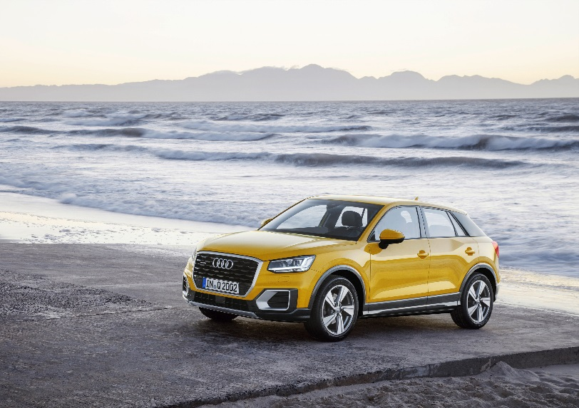
The all-new Audi Q2

MALAYSIA, MARCH 4, 2019 – Audi extends its Q family with a compact SUV. The Audi Q2* is an urban-type vehicle for everyday driving and recreation, bundling a progressive design with a high level of functionality. Connectivity, infotainment and assistance systems are on level of full-size class.

“In the Audi Q2 we have developed a distinctively geometric form language with special design characteristics specific to this model. The car thus exhibits an independent character within the Q family,” explains Audi Head of Design Marc Lichte.

Robust look: the exterior design
The result: a powerful SUV that is sharp and edgy. At the front, a strong image is created by the Singleframe grille in octagonal design that is positioned high as well as large air inlets. Especially eye-catching is the low roof that descends and merges into the C-pillars with color offset blades. This contrast accentuates the sportiness of the Audi Q2. The rear body terminates in a dynamic way with a long roof edge spoiler and a diffuser that has an underbody-protection look. In a side view, the high window line is especially eye-catching as are the concave flanks in the door area. The latter emphasize the wheel housings and thereby the quattro character of the compact SUV. The vehicle measures 1.51 meters tall and 1.79 meters wide. The overhangs are short with a vehicle length of 4.19 meters and a wheelbase of 2.60 meters, which means it will fit in any parking space.

Functional: the interior
The interior of the Q2, which takes up the taut and angular form language of the exterior, offers space for five. The four doors open wide, entry is comfortable and visibility is good, however seating positions for the driver and front passenger are sporty. The luggage compartment can handle 405 liters of cargo, and luggage capacity increases to 1,050 liters when the rear bench seat back is folded.

TFSI engines
The Audi Q2 is launched in Malaysia with a powerful and efficient 1.4 TFSI (110 kW/150 hp) with cylinder deactivation COD (cylinder on demand). The COD system deactivates the second and third cylinder at loads up to 100 Nm and while coasting when engine speed is between 1,400 and 3,200 rpm. With S tronic, the engine consumes on average 5.2 liters and emits 119 grams CO₂ per kilometer.

New dual-clutch transmission: power transfer
Audi offers the S tronic dual-clutch transmission with seven speeds in combination with all engines. It impresses with widely spaced gear ratios and a high level of efficiency that is attributable to a new type of oil supply and reduced friction.

Top solutions: chassis
Progressive steering is standard. In this system the toothing of the steering rack is designed to vary the steering gear ratio according to the steering input. With large steering movements it is more direct, making driving more dynamic.

The Audi drive select handling system lets the driver choose between five modes: auto, comfort, dynamic, efficiency and individual. It influences a variety of vehicle systems, including the steering and gear shift characteristics as well as the optional suspension with adaptive damper control. With ESC Offroad mode and nearly 15 centimeters (5.9 in) of ground clearance, the Q2 is also well-suited to rugged terrain.

Individual style: exterior and interior
Q2 customers can configure the look of their car according to their wishes in many aspects. Add-on parts, which vary according to the trim line, give the SUV a sporty or typical off-road appearance. The two lines design and sport are positioned above the base car.

Audi Genuine Accessories as either factory-installed options or retrofit equipment from an Audi partner offer additional customization solutions: add-on parts of carbon, the offroad style package and film designs for many areas of the body.

Customers also have many ways to express their personal style in the elaborately crafted interior. Colors like yellow, orange and red may be selected for inlays, sections of the seats and contrasting stitching. Inlays are also available in white plastic or brushed aluminum. Seat upholstery choices range from high-end fabrics to fine Nappa leather. At night, the LED lighting package makes the interior especially attractive. In the top version, LED light guides illuminate the sculpted inlays at the front of the instrument panel and the center console with homogeneous light. Drivers can use the MMI to choose from ten colors.

For more information on the brand and various car models from Audi Malaysia, visit their official website at http://www.audi.com.my/sea/web/my.html

– End –

Fuel consumption of the models named above:

Audi Q2:
Combined fuel consumption in l/100km: 5.2
Combined CO2 emissions in g/km: 119

* Fuel consumption and CO2 emissions figures given by based on the standard version offered in Malaysia.

The Audi Group, with its brands Audi, Ducati and Lamborghini, is one of the most successful manufacturers of automobiles and motorcycles in the premium segment. It is present in more than 100 markets worldwide and produces at 16 locations in twelve countries. 100 percent subsidiaries of AUDI AG include Audi Sport GmbH (Neckarsulm), Automobili Lamborghini S.p.A. (Sant’Agata Bolognese, Italy) and Ducati Motor Holding S.p.A. (Bologna, Italy).

In 2017, the Audi Group delivered to customers about 1.878 million automobiles of the Audi brand, 3,815 sports cars of the Lamborghini brand and 55,900 motorcycles of the Ducati brand. In the 2017 fiscal year, AUDI AG achieved total revenue of €60.1 billion and an operating profit of €5.1 billion. At present, approximately 90,000 people work for the company all over the world, more than 60,000 of them in Germany. Audi focuses on sustainable products and technologies for the future of mobility.

